

SALON STELATA SYSTEM

JAVA FINAL PROJECT



*Contents*

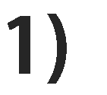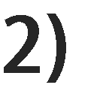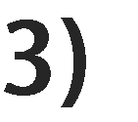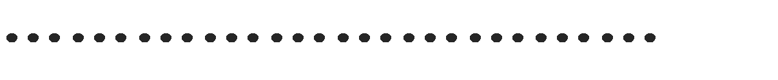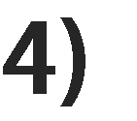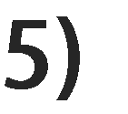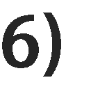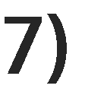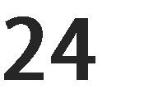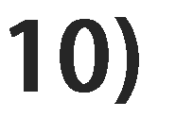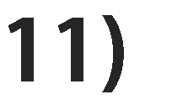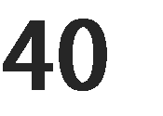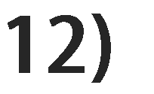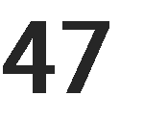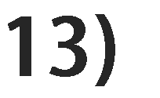

Introduction



**I am Umeshika Dissanayaka who is the student of the Diploma of Software Engineering coure at the ESOFT in Kiribathgoda . This is my Java Final Project. I selected the salon system to create it which is named “Stelata Salon System” has included 6 forms and 5 tables such as Staff Detail,Product Detail,Customer Details ,Service Detail,Products Detail and Menu.Futhermore I included three diagrams such as Use Case Diagram,Class Diagrams and ER Diagrams.Not only that this project has included flow chat and Acknowledgement . In my point of view Stelata Salon System is basic salon system.Hence everyone can easily use it. In conclusion I wil expect to develop it in advance one.**





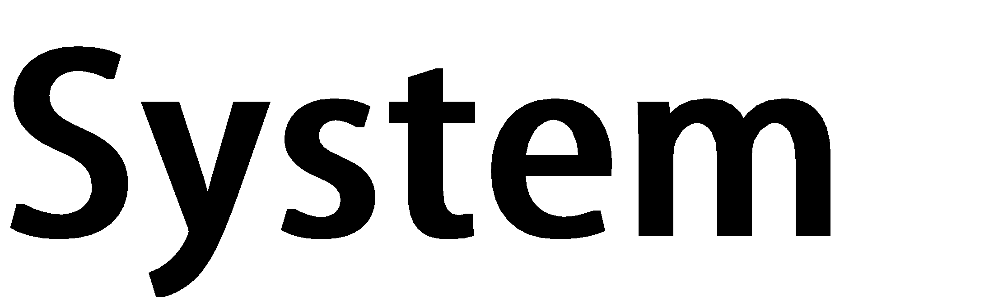



**Start**



yes



yes



n

o



no



yes



no



yes



no



**Input the login detail**



**Get the Menu from and select the**

**form**



**If you select staff**

**detail form**



**If you select**

**customer detail**

**form**



**If you select**

**service detail**



**Display**

**staff detail**

**form**



**Display customer detail**

**form**



**Display service**

**detail form**



**Display Products**

**detail form**



**Stop**



**If login detail**

**is**

**correct**







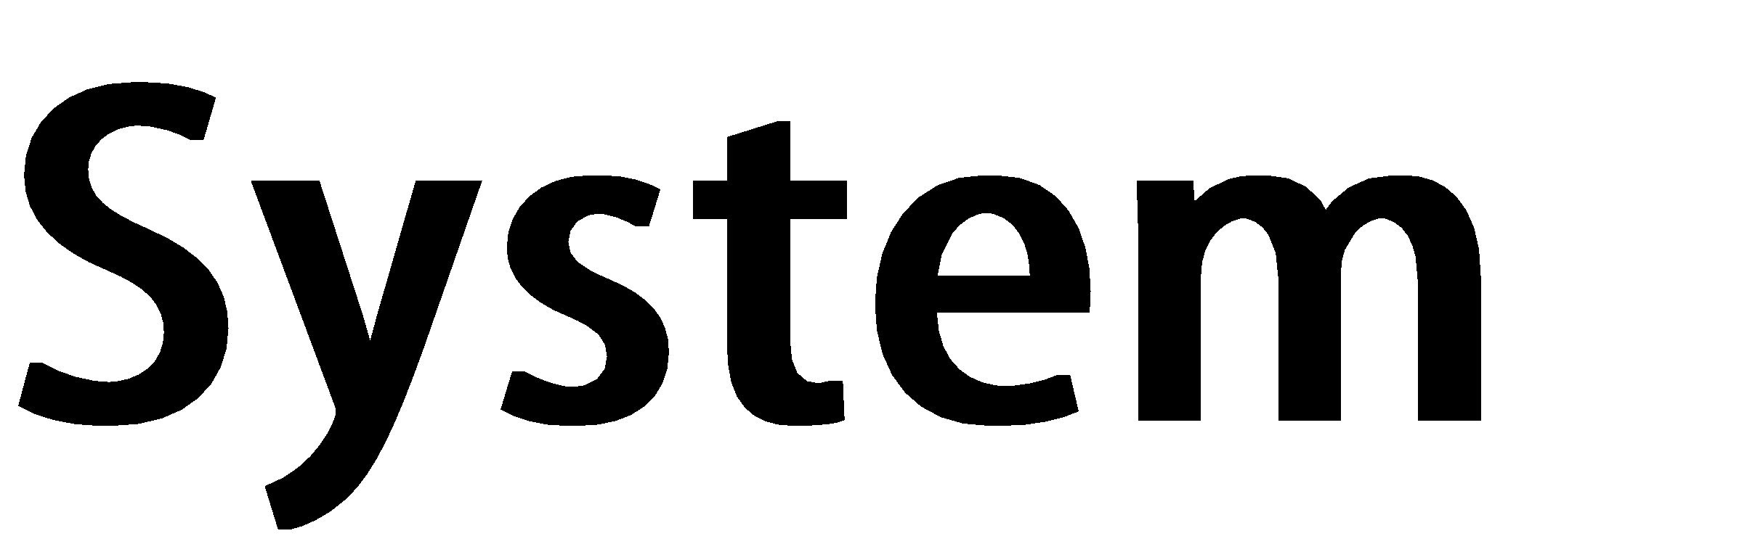



**Customer**



Book date, time for service



Register customer detail



Give service detail



Give product detail



Register staff detail



Give

appointment detail



Give service



Sell products



Give service bill



Pay for bill



Bill system



**Receptionist**



**Staff**



Select service type



Ask about appointment







**……\***

**+1**



**….\***

**+1**



**+1…..\***



**….\***

**+1**



**+1…..\***



**+1…..\***



**+1…..\***



**Billing System**



**Receptionist**



**Email: string**

**+**

**+**

**Pass word: string**



**+**

**register customer detail**

**()**

**+**

**register staff detail**

**()**

**+**

**()**

**get appointment**

**give appointment detail to staff**

**+**

**()**

**()**

**+**

**give service detail to customer**

**+**

**give product detail to customer**

**()**



**Customer**



**First Name: string**

**+**

**Email: string**

**+**

**Customer No. : int**

**+**

**Gender: string**

**+**

**TP: int**

**+**



**Ask about appointment**

**+**

**()**

**+**

**Select**

**service type ()**

**()**

**Book date & time for service**

**+**

**+**

**Pay for Service**

**()**

**+**

**()**

**buy Products**



**Staff**



**First Name: string**

**+**

**+**

**Email: string**

**+**

**Staff ID**

**:**

**int**

**+**

**Gender: string**

**+**

**TP: int**



**+**

**take appointment detail from reception**

**()**

**+**

**give service to**

**customer ()**

**+**

**sell cosmetics and Products**

**()**

**+**

**give service bill**

**()**



**+**

**Billing Form: string**

**+**

**Customer No: int**



**Billing Information**

**+**

**()**





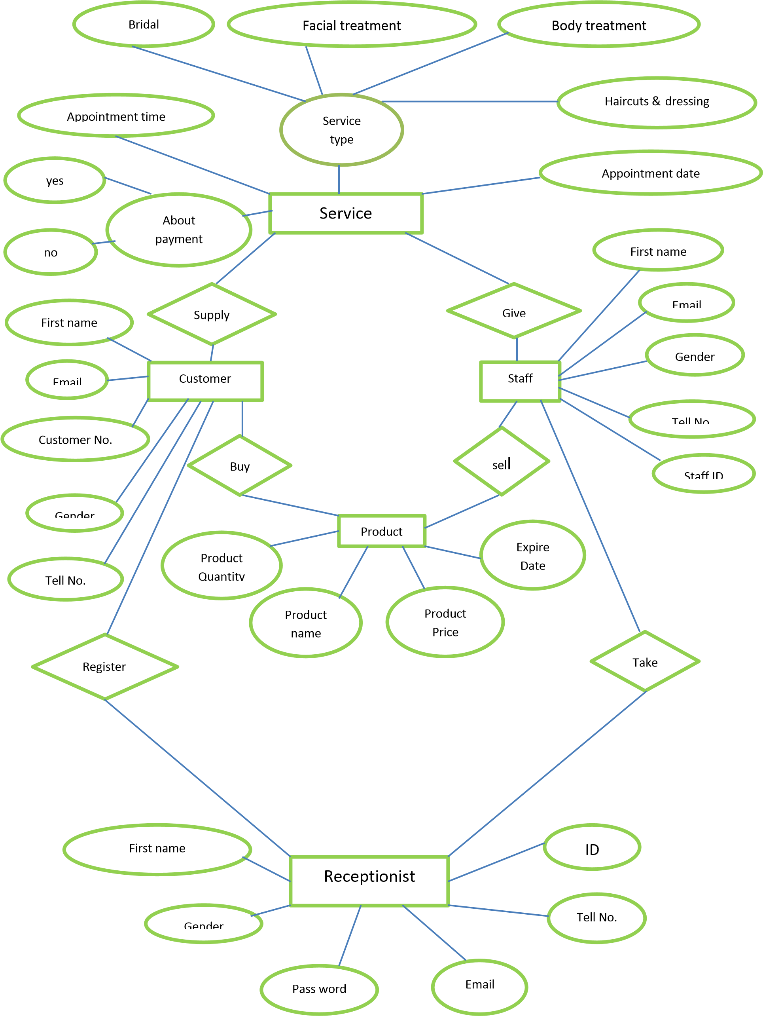



A system for managing a hair salon. This system keeps track of employee data, inventory and customer data along with billing. This is a fully equipped system that alone manages the entire functioning of a hair salon. It maintains stock of inventory coming in.

It also manages individual employee data. The system is even equipped to manage customer billing and data storage.

**The system works as follows:**

• Administrator may login to the system.

• He may manage and check menu form after get each forms due date, service and appointment to be made.

• The system also keeps track of inventory coming in.

• An employee login is also present for customer registration.

• As the employee enters various services, the system updates the data and generates the detail.

• This customer data is also separately stored in a database.

**Advantages**

• As the system is fully and basically used, it does not difficult to maintain customer’s detail.

• Also it maintains records of all the employees along with their service detail so there would be systematic way of payment.

• Saves efforts and time and it is cost-effective.

**Disadvantages**

• Requires large database

• The admin has to manually manage the inventory section in the system like what item have been used or sold and what items are coming.





package salon_stelata;

import java.sql.*;

import javax.swing.JOptionPane;

public class Login_Form extends javax.swing.JFrame {

public Connection conn;

public Statement state;

public Login_Form() {

initComponents();

try

{

Class.forName("com.mysql.jdbc.Driver" );

conn=DriverManager.getConnection("jdbc:mysql://localhost:3306/salon_stelata","root","");

state=conn.createStatement();

JOptionPane.showMessageDialog(null, "Connected");

}

catch( Exception e){JOptionPane.showMessageDialog(null, e+"Error in connecting to database!");}

private void btnloginActionPerformed(java.awt.event.ActionEvent evt) {

System.out.println(tbemail.getText()+tbpassword.getText());

String sql = "Select * from login_detail where Email=? and Password=?";

System.out.println("conted");

try{

PreparedStatement pst = conn.prepareStatement(sql);

pst.setString(1, tbemail.getText());

pst.setString(2, tbpassword.getText());

System.out.println(tbemail.getText()+tbpassword.getText());

ResultSet rs = pst.executeQuery();

if(rs.next()){

JOptionPane.showMessageDialog(null, "Welcome Stelata Salon System");

new Menu_Form().setVisible(true);

this.hide();

}else{

JOptionPane.showMessageDialog(null, "Please enter the email & password !");

}

}catch(Exception ex){

JOptionPane.showMessageDialog(null, "SQLWrong"+ex);

}

}

private void tbpasswordActionPerformed(java.awt.event.ActionEvent evt) {

// TODO add your handling code here:

}

private void btnsaveActionPerformed(java.awt.event.ActionEvent evt) {

// TODO add your handling code here:

try { Class.forName("com.mysql.jdbc.Driver");

conn=DriverManager.getConnection("jdbc:mysql://localhost:3306/salon_stelata","root","");

state=conn.createStatement();

JOptionPane.showMessageDialog(null,"Saved Data");

String email= tbemail.getText();

String pass= tbpassword.getText();

String sql1="INSERT INTO login_detail(Email,Password)VALUES('"+email+"','"+pass+"')";

state.executeUpdate(sql1);

}

catch (Exception e)

{JOptionPane.showMessageDialog(this,e.getMessage());

}

}

private void btnexitActionPerformed(java.awt.event.ActionEvent evt) {

System.exit(0);

}

private void btnclearActionPerformed(java.awt.event.ActionEvent evt) {

// TODO add your handling code here:

tbemail.setText("");

tbpassword.setText("");

}

/**

* @param args the command line arguments

*/

public static void main(String args[]) {

**Login Form Design**

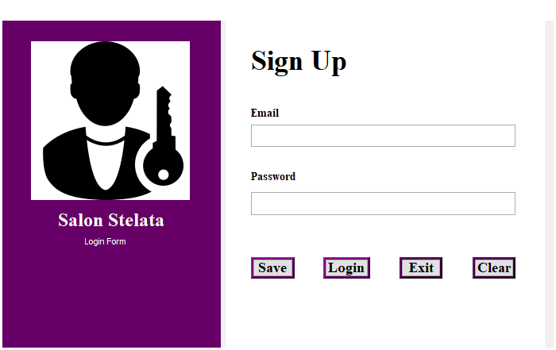

**Login Detail-Query**

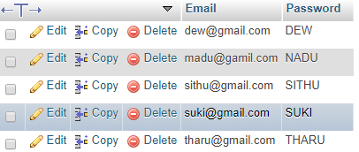

**SQL Login Table Design view**

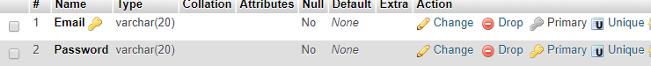

**Menu Form**

**Menu Form-Coding**

package salon_stelata;

import java.sql.*;

import javax.swing.JOptionPane;

public class Menu_Form extends javax.swing.JFrame {

public Connection conn;

public Statement state;

public Menu_Form() {

initComponents();

try

{

Class.forName("com.mysql.jdbc.Driver" );

conn=DriverManager.getConnection("jdbc:mysql://localhost:3306/salon_stelata","root","");

state=conn.createStatement();

JOptionPane.showMessageDialog(null, "Connected");

}

catch( Exception e){JOptionPane.showMessageDialog(null, e+"Error in connecting to database!");}

}

private void btnstaffActionPerformed(java.awt.event.ActionEvent evt) {

new Staff_Detail().setVisible(true);

this.hide();

}

private void btnexitActionPerformed(java.awt.event.ActionEvent evt) {

System.exit(0);

}

private void btnbackActionPerformed(java.awt.event.ActionEvent evt) {

new Login_Form().setVisible(true);

this.hide();

}

private void btncustomerActionPerformed(java.awt.event.ActionEvent evt) {

new Customer_Detail().setVisible(true);

this.hide();

}

private void btnserviceActionPerformed(java.awt.event.ActionEvent evt) {

new Service_Detail().setVisible(true);

this.hide();

}

private void btnproductActionPerformed(java.awt.event.ActionEvent evt) {

new Product_Detail().setVisible(true);

this.hide();

}

**Menu Form Design**

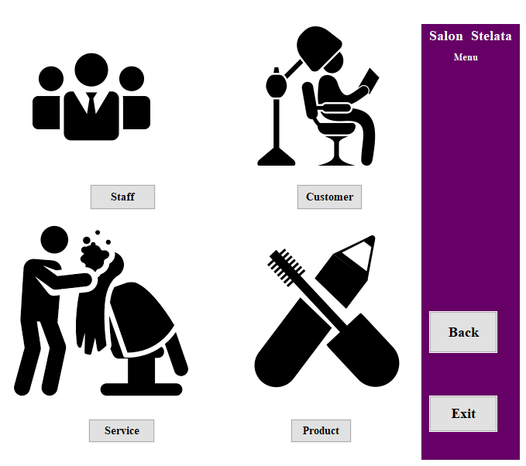

**Staff Detail Form**

**Staff Detail Form- Coding**

package salon_stelata;

import java.sql.*;

import javax.swing.JOptionPane;

public class Staff_Detail extends javax.swing.JFrame {

public Connection conn;

public Statement state;

public Staff_Detail() {

initComponents();

try

{

Class.forName("com.mysql.jdbc.Driver" );

conn=DriverManager.getConnection("jdbc:mysql://localhost:3306/salon_stelata","root","");

state=conn.createStatement();

JOptionPane.showMessageDialog(null, "Connected");

}

catch( Exception e){JOptionPane.showMessageDialog(null, e+"Error in connecting to database!");

}

private void btnsaveActionPerformed(java.awt.event.ActionEvent evt) {

// TODO add your handling code here:

try { Class.forName("com.mysql.jdbc.Driver");

conn=DriverManager.getConnection("jdbc:mysql://localhost:3306/salon_stelata","root","");

state=conn.createStatement();

JOptionPane.showMessageDialog(null,"Saved Data!");

String fn=tbfname.getText();

String email=tbemail.getText();

String id=tbsid.getText();

String gender=tbgender.getText();

String tell=tbtell.getText();

String sql1="INSERT INTO staff_detail (FirstName,Email,StaffID,Gender,TP)VALUES('"+fn+"','"+email+"','"+id+"','"+gender+"','"+tell+"')";

state.executeUpdate(sql1);

}

catch(Exception e){JOptionPane.showMessageDialog(this,e.getMessage());}

}

private void btnbackActionPerformed(java.awt.event.ActionEvent evt) {

new Menu_Form().setVisible(true);

this.hide();

}

private void btnupdateActionPerformed(java.awt.event.ActionEvent evt) {

try { Class.forName("com.mysql.jdbc.Driver");

conn=DriverManager.getConnection("jdbc:mysql://localhost:3306/salon_stelata","root","");

state=conn.createStatement();

JOptionPane.showMessageDialog(null,"Updated Data");

String fn=tbfname.getText();

String email=tbemail.getText();

String id=tbsid.getText();

String gender=tbgender.getText();

String tell=tbtell.getText();

String sql2="UPDATE staff_detail SET FirstName='"+fn+"',Email='"+email+"',Gender='"+gender+"',StaffID='"+id+"',TP='"+tell+"'WHERE FirstName='"+fn+"'";

state.executeUpdate(sql2);}

catch (Exception e){JOptionPane.showMessageDialog(this,e.getMessage());}

}

private void btnclearActionPerformed(java.awt.event.ActionEvent evt) {

// TODO add your handling code here:

tbfname.setText("");

tbemail.setText("");

tbsid.setText("");

tbgender.setText("");

tbtell.setText("");

}

private void btnexitActionPerformed(java.awt.event.ActionEvent evt) {

System.exit(0);

}

private void btndeleteActionPerformed(java.awt.event.ActionEvent evt) {

try { Class.forName("com.mysql.jdbc.Driver");

conn=DriverManager.getConnection("jdbc:mysql://localhost:3306/salon_stelata","root","");

state=conn.createStatement();

JOptionPane.showMessageDialog(null,"Delete the Data");

String sql3="DELETE FROM staff_detail WHERE Email='"+tbemail.getText()+"'";

state.executeUpdate(sql3);}

catch(Exception e){JOptionPane.showMessageDialog(this,e.getMessage());}

}

**Staff Detail Form Design**

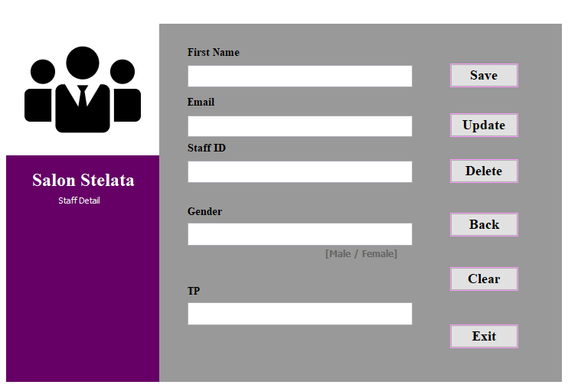

**Staff Detail- Query**

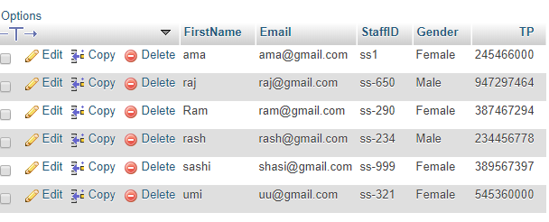

**SQL Staff Detail Table Design View**

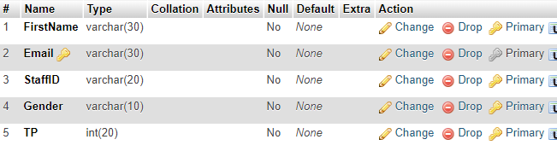

# Customer Detail Form

**Customer Detail Form-Coding**

package salon_stelata;

import java.sql.*;

import javax.swing.JOptionPane;

public class Customer_Detail extends javax.swing.JFrame {

public Connection conn;

public Statement state;

public Customer_Detail() {

initComponents();

try

{

Class.forName("com.mysql.jdbc.Driver" );

conn=DriverManager.getConnection("jdbc:mysql://localhost:3306/salon_stelata","root","");

state=conn.createStatement();

JOptionPane.showMessageDialog(null, "Connected");

}

catch( Exception e){JOptionPane.showMessageDialog(null, e+"Error in connecting to database!");

}

private void btnexitActionPerformed(java.awt.event.ActionEvent evt) {

System.exit(0) }

private void btnclearActionPerformed(java.awt.event.ActionEvent evt) {

tbfname.setText("");

tbemail.setText("");

tbcusno.setText("");

tbgender.setText("");

tbtell.setText(""); }

private void btndeleteActionPerformed(java.awt.event.ActionEvent evt) {

try { Class.forName("com.mysql.jdbc.Driver");

conn=DriverManager.getConnection("jdbc:mysql://localhost:3306/salon_stelata","root","");

state=conn.createStatement();

JOptionPane.showMessageDialog(null,"Delete the Data");

String sql3="DELETE FROM customer_detail WHERE Email='"+tbemail.getText()+"'";

state.executeUpdate(sql3);}

catch(Exception e){JOptionPane.showMessageDialog(this,e.getMessage());}

}

private void btnbackActionPerformed(java.awt.event.ActionEvent evt) {

new Menu_Form().setVisible(true);

this.hide();

}

private void btnupdateActionPerformed(java.awt.event.ActionEvent evt) {

try { Class.forName("com.mysql.jdbc.Driver");

conn=DriverManager.getConnection("jdbc:mysql://localhost:3306/salon_stelata","root","");

state=conn.createStatement();

JOptionPane.showMessageDialog(null,"Updated Data");

String fn=tbfname.getText();

String email=tbemail.getText();

String cusno=tbcusno.getText();

String gender=tbgender.getText();

String tell=tbtell.getText();

String sql2="UPDATE customer_detail SET FirstName='"+fn+"',Email='"+email+"',CustomerNo='"+cusno+"',Gender='"+gender+"',TP='"+tell+"'WHERE FirstName='"+fn+"'";

state.executeUpdate(sql2);}

catch (Exception e){JOptionPane.showMessageDialog(this,e.getMessage());}

}

private void btnsaveActionPerformed(java.awt.event.ActionEvent evt) {

try { Class.forName("com.mysql.jdbc.Driver");

conn=DriverManager.getConnection("jdbc:mysql://localhost:3306/salon_stelata","root","");

state=conn.createStatement();

JOptionPane.showMessageDialog(null,"Saved Data!");

String fn=tbfname.getText();

String email=tbemail.getText();

String cusno=tbcusno.getText();

String gender=tbgender.getText();

String tell=tbtell.getText();

String sql1="INSERT INTO customer_detail (FirstName,Email,CustomerNo,Gender,TP)VALUES('"+fn+"','"+email+"','"+cusno+"','"+gender+"','"+tell+"')";

state.executeUpdate(sql1);

}

catch(Exception e){JOptionPane.showMessageDialog(this,e.getMessage());}

}

## **Customer Detail Form Design**

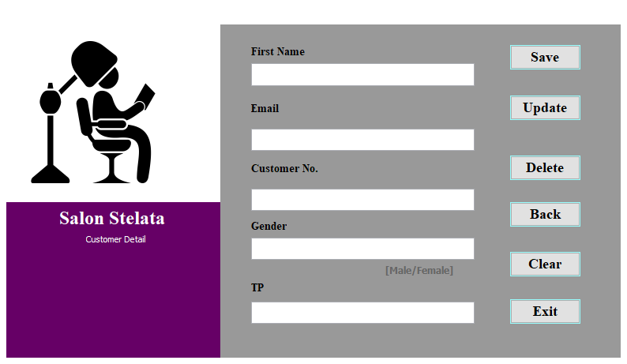

**Customer Detail – Query**

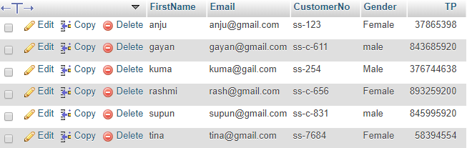

**SQL Customer Detail Table Design View**

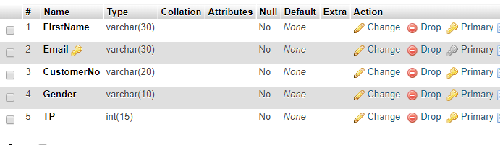

# Service Detail Form

# 

**Service Detail Form-Coding**

package salon_stelata;

import java.sql.*;

import javax.swing.JOptionPane;

public class Service_Detail extends javax.swing.JFrame {

public Connection conn;

public Statement state;

public Service_Detail() {

initComponents();

try

{

Class.forName("com.mysql.jdbc.Driver" );

conn=DriverManager.getConnection("jdbc:mysql://localhost:3306/salon_stelata","root","");

state=conn.createStatement();

JOptionPane.showMessageDialog(null, "Connected");

}

catch( Exception e){JOptionPane.showMessageDialog(null, e+"Error in connecting to database!");}

}

private void tbcusnoActionPerformed(java.awt.event.ActionEvent evt) {

// TODO add your handling code here:

}

private void btnbackActionPerformed(java.awt.event.ActionEvent evt) {

new Menu_Form().setVisible(true);

this.hide();

}

private void btnclearActionPerformed(java.awt.event.ActionEvent evt) {

tbcusno.setText("");

tbadate.setText("");

tbatime.setText("");

tbyn.setText("");

tbst.setText("");

}

private void jTextField1ActionPerformed(java.awt.event.ActionEvent evt) {

// TODO add your handling code here:

}

private void btnback1ActionPerformed(java.awt.event.ActionEvent evt) {

// TODO add your handling code here:

System.exit(0);

}

private void btnsaveActionPerformed(java.awt.event.ActionEvent evt) {

// TODO add your handling code here:

try { Class.forName("com.mysql.jdbc.Driver");

conn=DriverManager.getConnection("jdbc:mysql://localhost:3306/salon_stelata","root","");

state=conn.createStatement();

JOptionPane.showMessageDialog(null,"Saved Data!");

String adate=tbadate.getText();

String atime=tbatime.getText();

String cusno=tbcusno.getText();

String st=tbst.getText();

String yn=tbyn.getText();

String sql1="INSERT INTO service_detail (AppointmentDate,AppointmentTime,CustomerNo,ServiceType,Payappointmentcharges)VALUES('"+adate+"','"+atime+"','"+cusno+"','"+st+"','"+yn+"')";

state.executeUpdate(sql1);

}

catch(Exception e){JOptionPane.showMessageDialog(this,e.getMessage());}

}

**Service Detail Form-Design**

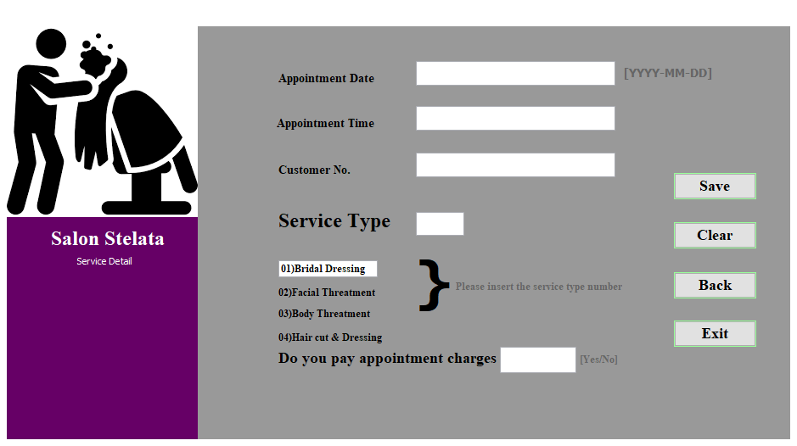

**Service Detail-Query**

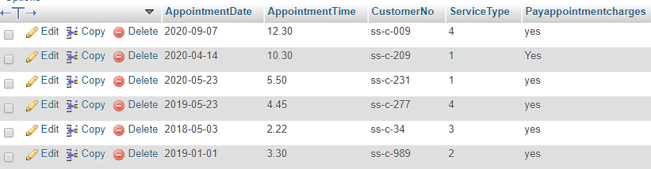

**SQL Service Detail table design view**

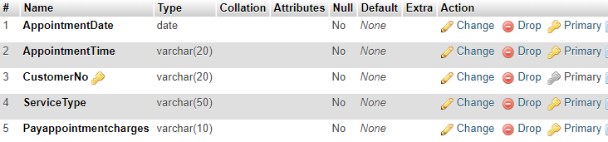

# Products Detail Form

**Product Detail Form-Coding**

package salon_stelata;

import java.sql.*;

import javax.swing.JOptionPane;

public class Product_Detail extends javax.swing.JFrame {

public Connection conn;

public Statement state;

public Product_Detail() {

initComponents();

try

{

Class.forName("com.mysql.jdbc.Driver" );

conn=DriverManager.getConnection("jdbc:mysql://localhost:3306/salon_stelata","root","");

state=conn.createStatement();

JOptionPane.showMessageDialog(null, "Connected");

}

catch( Exception e){JOptionPane.showMessageDialog(null, e+"Error in connecting to database!");}

}

private void btnclearActionPerformed(java.awt.event.ActionEvent evt) {

tbpname.setText("");

tbedate.setText("");

tbpprice.setText("");

tbpquantity.setText(""); }

private void btnsaveActionPerformed(java.awt.event.ActionEvent evt) {

// TODO add your handling code here:

try { Class.forName("com.mysql.jdbc.Driver");

conn=DriverManager.getConnection("jdbc:mysql://localhost:3306/salon_stelata","root","");

state=conn.createStatement();

JOptionPane.showMessageDialog(null,"Saved Data");

String pn=tbpname.getText();

String ed=tbedate.getText();

String pp=tbpprice.getText();

String pq= tbpquantity.getText();

String sql1="INSERT INTO product_detail(ProductName,ExpireDate,ProductQuantity,ProductPrice)VALUES('"+pn+"','"+ed+"','"+pq+"','"+pp+"')";

state.executeUpdate(sql1);

}

catch (Exception e)

{JOptionPane.showMessageDialog(this,e.getMessage());

}

}

private void btnbackActionPerformed(java.awt.event.ActionEvent evt) {

new Menu_Form().setVisible(true);

this.hide();

}

private void btnexitActionPerformed(java.awt.event.ActionEvent evt) {

System.exit(0);

}

**Product Detail Form-Design**

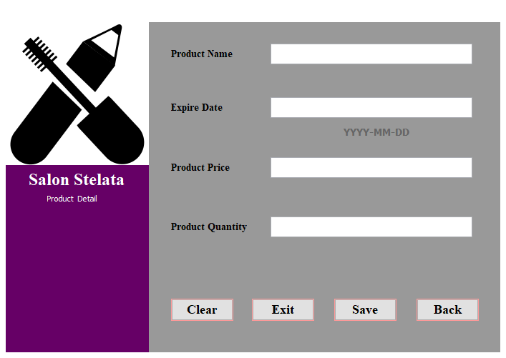

**Product Detail-Query**

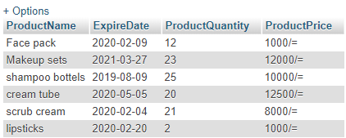

**SQL Product Detail table design view**

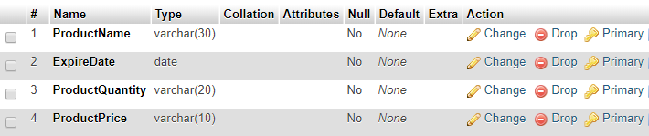

# Thank you



***Thank you for providing me with the knowledgement of lessons of***

***software Engineering ,C#, and java .Which I need to face my future***

***higher***

***studies .You***

***would always be my best teaches***

***specially thank yo***

***u***

***Mrs.Hiroshi***

***Weerakoon***

***& Mrs.Kaushalaya***

***Gunarathna***

***. Both of you put***

***in to teach me the lessons I needed to learn. Thank you for spending***

***valuable time to me, even when I wasn’t keen to learn.***